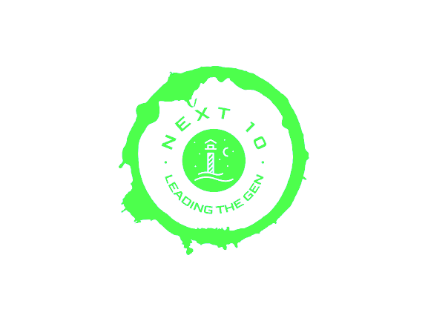

Team Name : Next 10

Team members : abdelkareem, mohammad, Hamza, zaid, Mohammad

Project : Leading the next generation V.1

# Who are we

We are the next 10 a team built from senior college students with a variety of backgrounds (specialization-wise) that agree that the educational system worldwide shares a gap which needs to be felled.

Identifying a college degree or specialization from its title leads to huge numbers of students studying and working in areas that don't fulfil their true passion and potential simply because they chose the wrong specialization based on brief and shallow understanding.

We believe that change doesn't require achieving the impossible that could be done through baby steps such as awareness lectures social media posts and some hard work moving on in this paper we will demonstrate how these steps took place as will as the results and the effectiveness on a small scale and measure.

# What did we do!

It all started with us getting gathered at the mind lab to take the school students and start the tour, at first we agreed to walk them around the college and show the facilities that are in and around the college (show capability) so they would understand and imagine the difference between college and school, afterwords we took them to the soft area so they would take a break plus do some interviews with students so they get a better idea about the specialization that they would enter in the future, then we moved to the old building where they played a bit of PlayStation 5 and had a launch, after it, we took them to a classroom and gave a session about engineering and Arduino then we took them back to the mind lab.

In conclusion

College is an exciting time for many young people, as they explore their new found freedom and independence. For school students , however, college can be a challenging experience. Without the guidance of parents or guardians, school students must learn how to navigate the college environment on their own. It is important that these students feel supported and happy during this time in order to make the most of their college experience. In this section, we will discuss ways to ensure that school students have a successful and enjoyable college experience. We will also explore strategies for creating an environment where school students can thrive and feel happy during their time at college.

# Massage from us for the next generation

You will shine and you will achieve whatever you want if you keep working hard and dreaming more.

Don't let anybody destroy your peace of mind. You are on the right path to pursue your dreams. You have to be ready to do whatever you are interested in. You are the hero of your family, society, community and your country.

Try to be proactive, self starter, quick learner and self motivator and don't have the fear of taking risk.

If you want to touch the sky, you have to accept that you may fall down so many times.

Regardless of how much people and your community interfere, be like stone in front of them and convince them with your ego and words.

Furthermore, be an inspiration to their children and add your name on the top of the real heroes for freedom of thoughts and humanity.

Keep motivating yourself, try thousands of ways and come up with the best version of yourself. Don't be disappointed when none of them work. You are not the only one who suffers, there are thousands more who suffer even more than you but they didn't quit, they started struggling even harder.

Dear my next generation, keep educating yourself and focus on your studies and find learning opportunities, don't follow peoples' negative thoughts and beliefs nor the culture instead inspire others to follow you and be a role model to your society, fellow classmates and colleagues.

TRY TO SPREAD HUMANITY AND UNITY AMONG OTHERS.

Don't lose hope, be as smart and as patient that nothing stops you from what you wish to achieve.

YOU ARE UNIQUE IN THE WAY YOU ARE.

You are lucky more than you think, just believe in yourself everything will come to you in the right time.

KEEP STRUGGLING AND SHINING!

# Our work

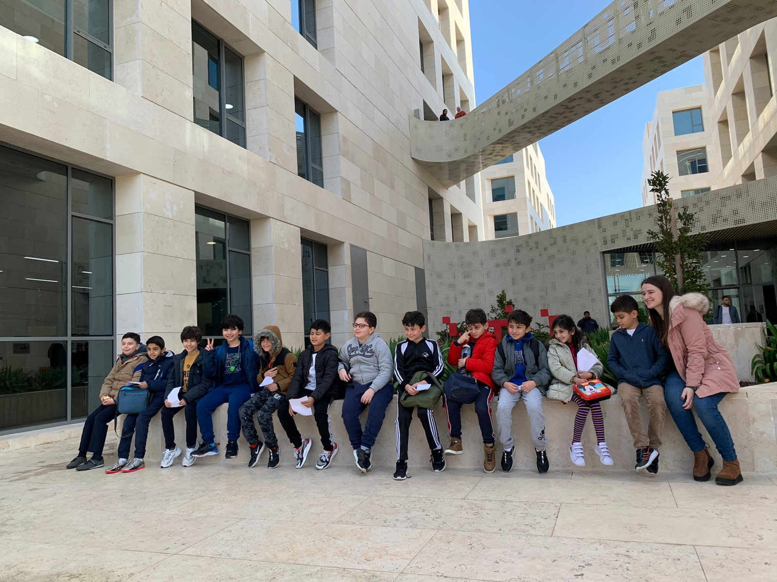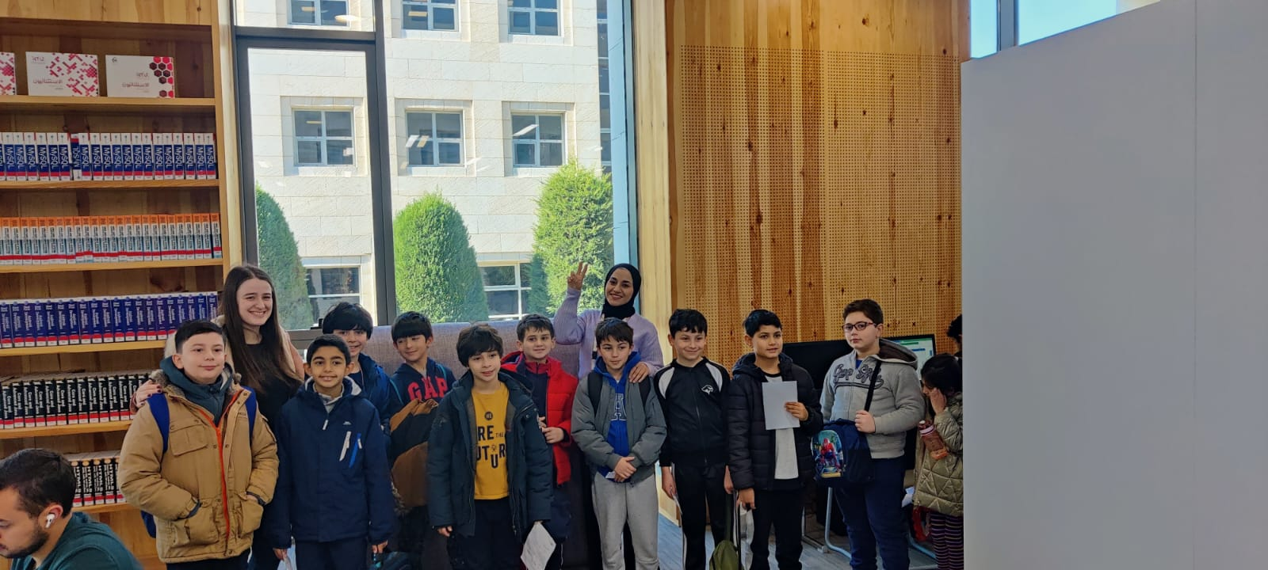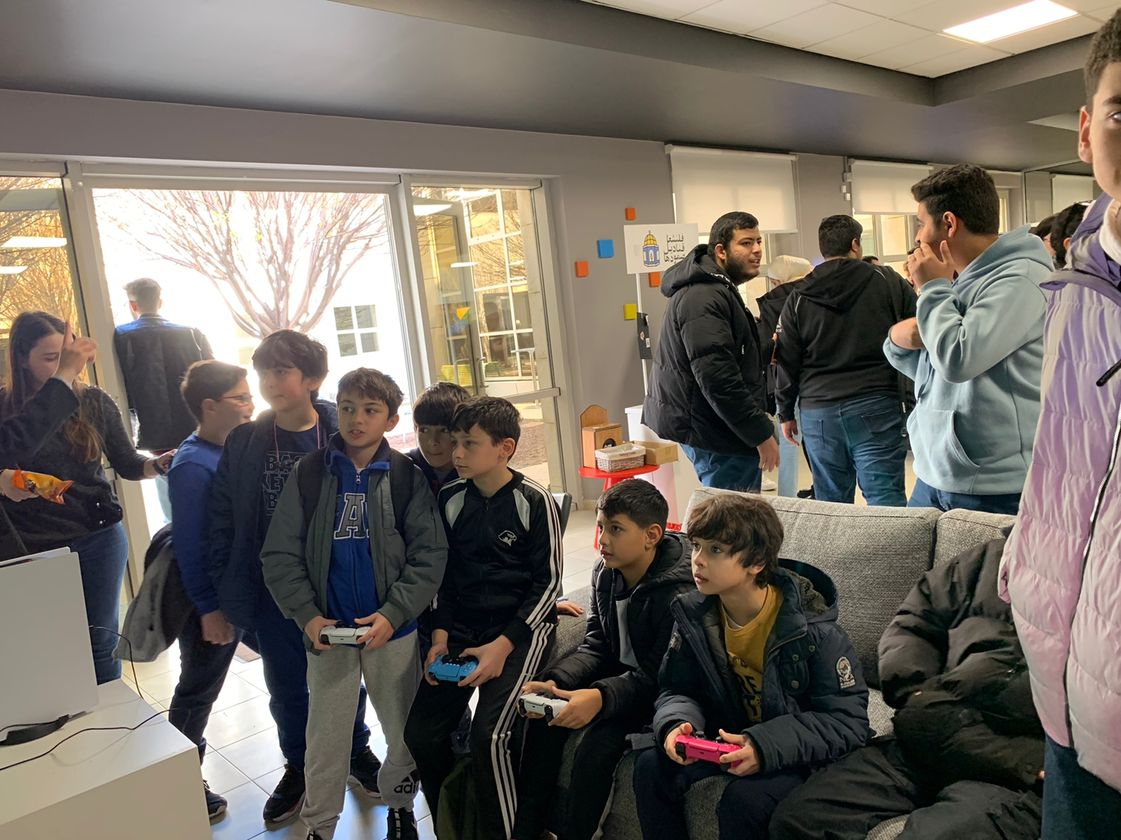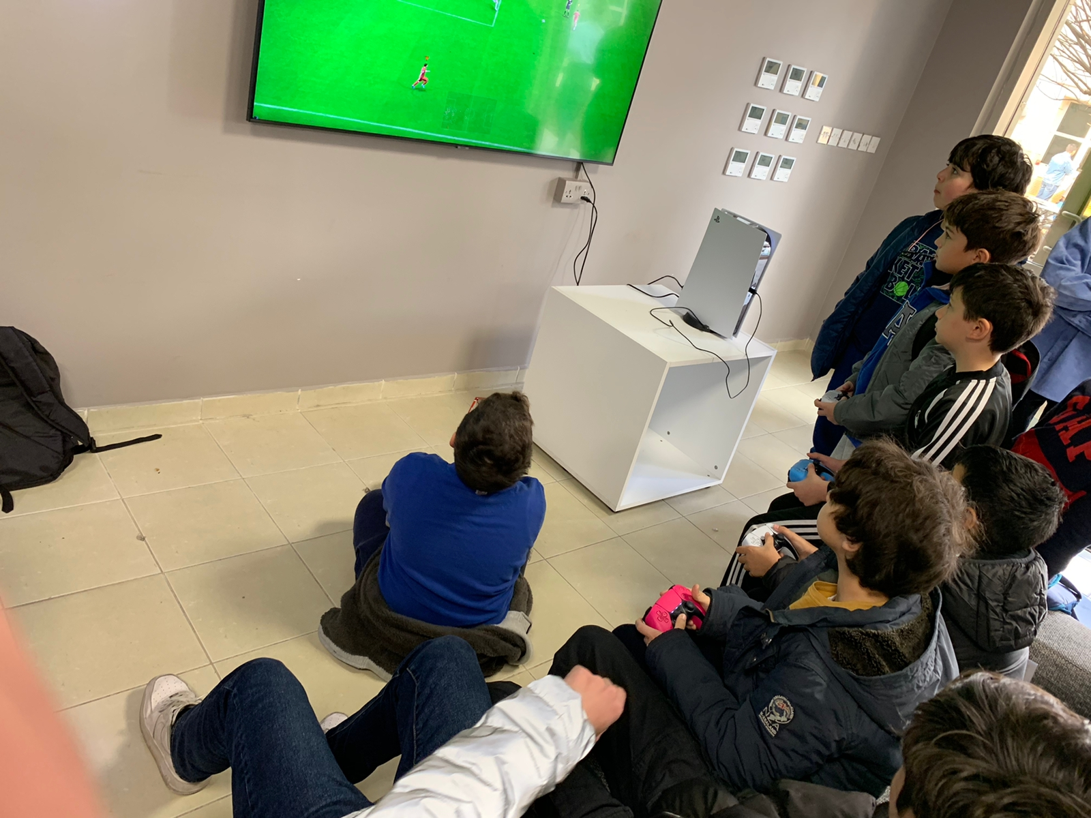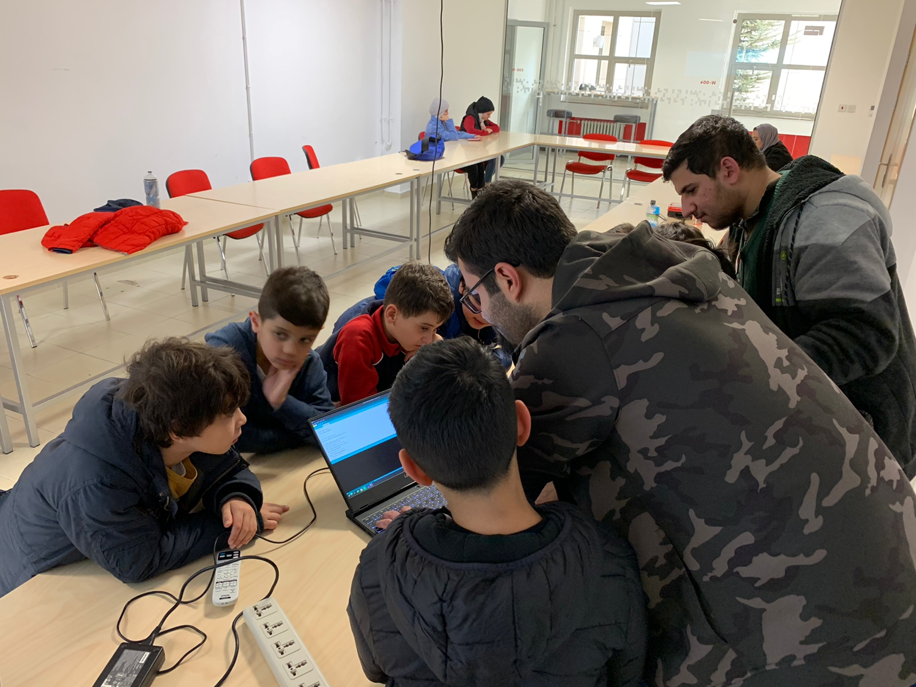

# Thank you <3